Exploratory testing of the site http://www.007museum.com/

The site is using an unsecure protocol (HTTP instead of HTTPS)

**Description:**

The site is using hypertext transfer protocol (HTTP) instead of hypertext transfer protocol secure (HTTPS) which could mean that the customer is not safe while using it.

**Used Device/Browser:**

- Chrome (Version 91.0.4472.77 (64-bit)) on Windows 10

**Steps to reproduce:**

* Open the <http://www.007museum.com/> page
* Observe that the URL does not contain HTTPS.
* Observe that the browser is giving you the “Not secure” alert.

**Screenshot:**

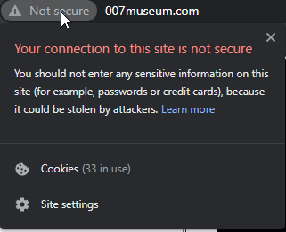

The banner on the page is too big and cluttered

**Description:**

The banner (logo) of the page is too big, and has a lot of small pictures in it instead of one cohesive image that represents the brand values of the company.

**Used Device/Browser:**

- Chrome (Version 91.0.4472.77 (64-bit)) on Windows 10

**Steps to reproduce:**

* Open the <http://www.007museum.com/> page
* Observe the banner on the landing page

**Screenshot:**

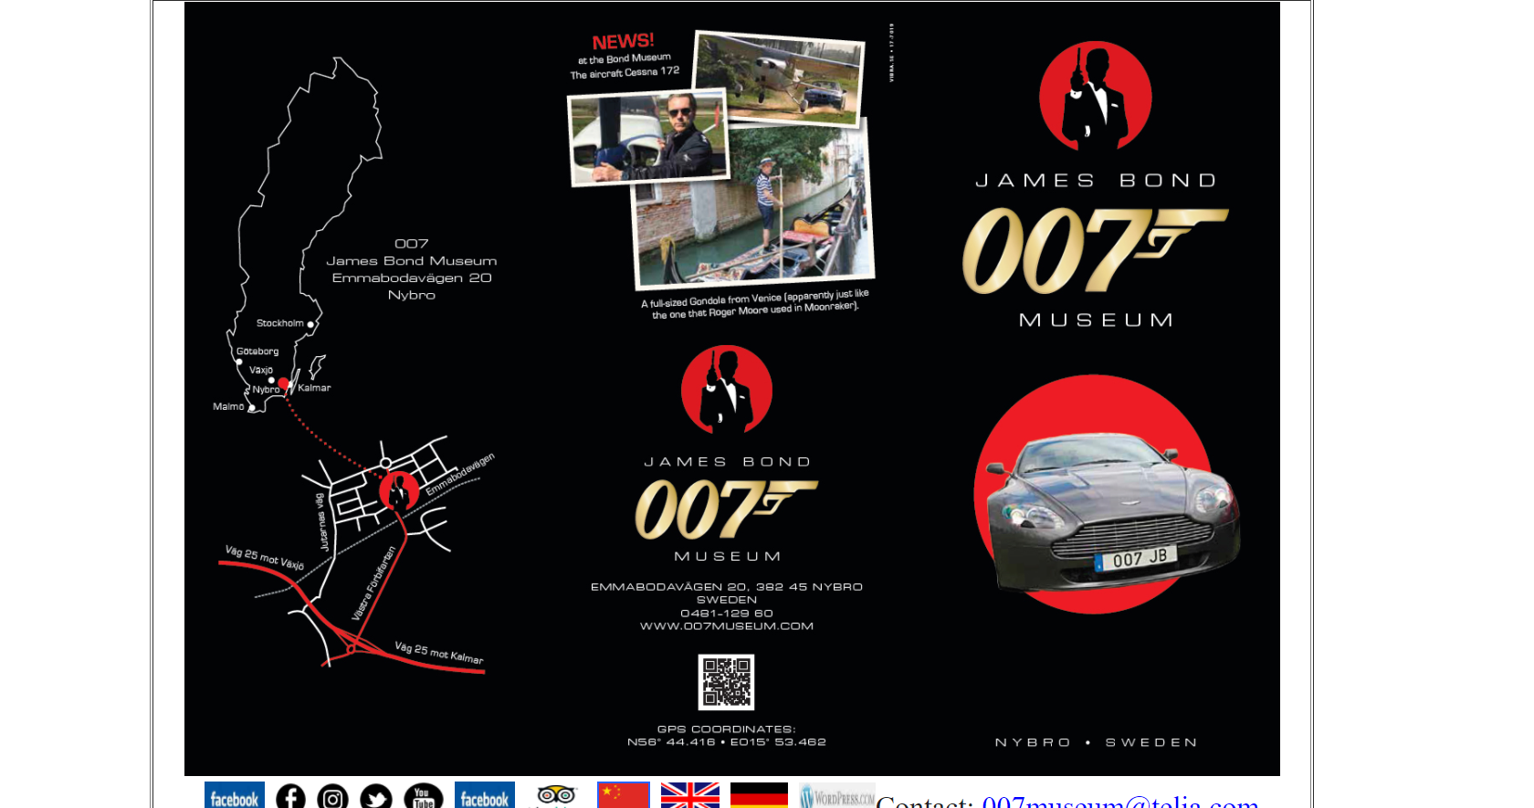

When you click on the banner it opens the same page but in the new tab

**Description:**

When you click on the banner instead of just taking you to the top it opens a new page with the same URL but the page opens in a new tab.

**Used Device/Browser:**

- Chrome (Version 91.0.4472.77 (64-bit)) on Windows 10

**Steps to reproduce:**

* Open the <http://www.007museum.com/> page
* Click on the banner on the landing page
* Observe how it opens the <http://www.007museum.com/> page but in the new tab.

**Screenshot:**

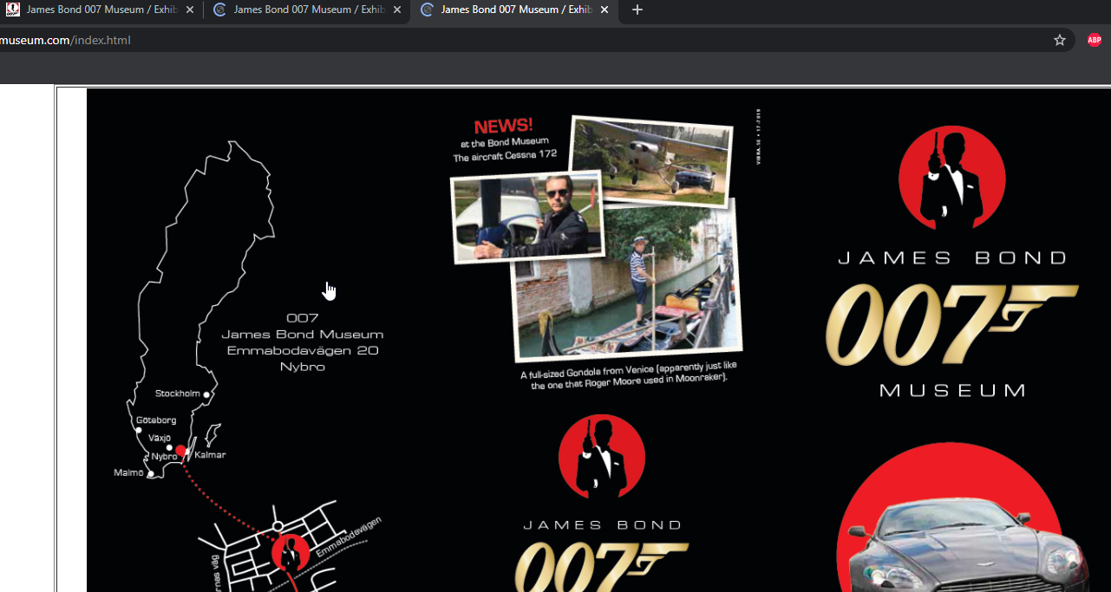

The site is one very long page and there are no navigation tools

**Description:**

The site is one long page, and you have to scroll for a long time until you find the information you need.

**Used Device/Browser:**

- Chrome (Version 91.0.4472.77 (64-bit)) on Windows 10

**Steps to reproduce:**

* Open the <http://www.007museum.com/> page
* Scroll down the page until the end of the site
* Notice how it takes an excruciatingly long time to reach the bottom of the page

**Screenshot:**

Click the link down below to reach the screenrecording:

<https://drive.google.com/file/d/1XdmhjRlLokJwuMGuQEr3hclr1aUsWpSE/view?usp=sharing>

The social media icons under the banner are cluttered with other links and there are three Facebook icons

**Description:**

The social media icons, and other links under the banner are cluttered all together, there are three Facebook links leading to three different pages. The first link has _ character.

**Used Device/Browser:**

- Chrome (Version 91.0.4472.77 (64-bit)) on Windows 10

**Steps to reproduce:**

* Open the <http://www.007museum.com/> page
* Observe the icons and links under the banner
* Observe how the first Facebook link has a _ caracter next to it instead of a different icon.
* Click on the second Facebook link and notice how it takes you to the James Bond 007 Museum Nybro Sweden page.
* Click on the first Facebook link and notice how it takes you to the same profile like the second one but just on the community page.

**Screenshot:**

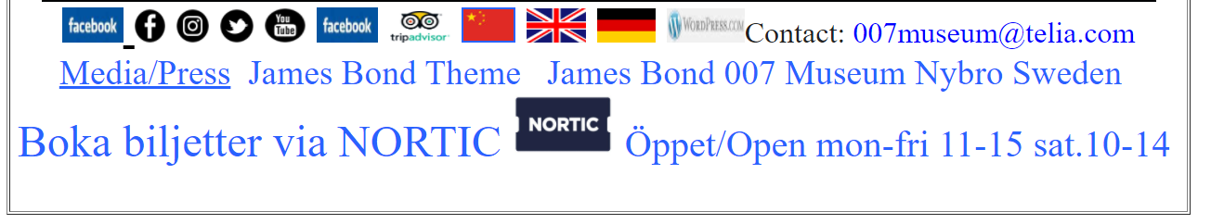

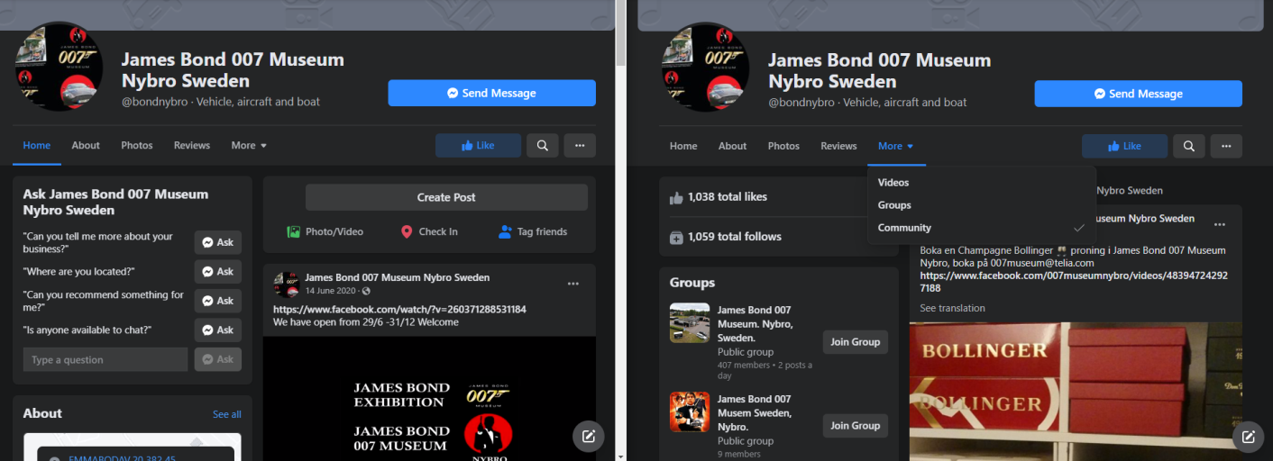

Clicking on the change language icons take you to a new page in a new tab that has only a part of the site translated

**Description:**

The change language icons when clicked take you to a new page in a new tab that has only a part of the site translated. The Chinese language translates only some things, the English has side by side Swedish and English which start to differ as you scroll down.

**Used Device/Browser:**

- Chrome (Version 91.0.4472.77 (64-bit)) on Windows 10

**Steps to reproduce:**

* Open the <http://www.007museum.com/> page
* Observe the icons and links under the banner
* Click on the China flag icon and observe the page it leads you on.
* Notice how only a part of the text is translated and notice how all the links under the banner are gone, exit from the tab.
* Click on the UK flag icon and observe how it takes you to a new page In a new tab and notice that there is a table with english translation on the left and Swedish on the right not aligned.
* Scroll down the page and notice that they start to differ ass you scrool down.

**Screenshot:**



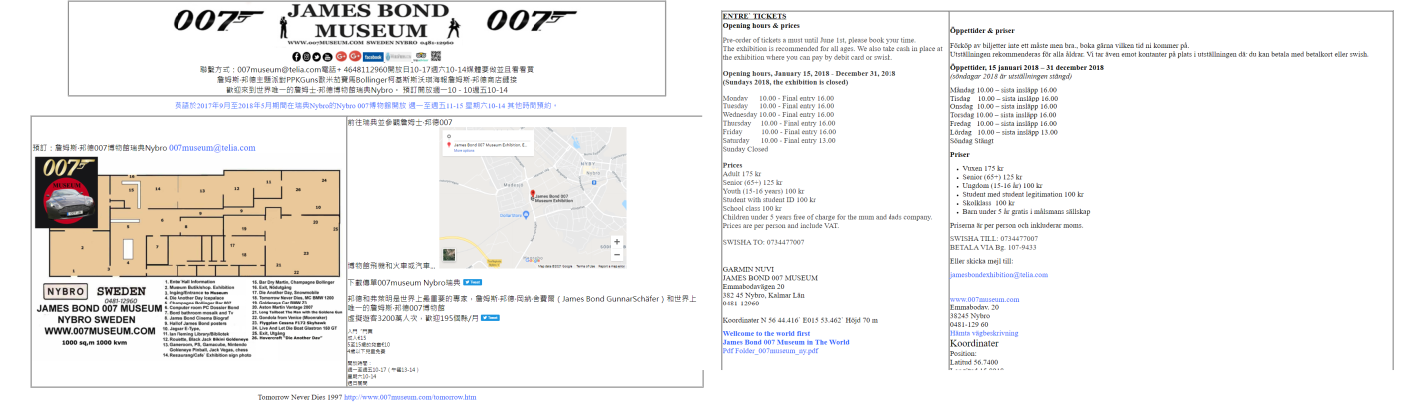

The blue Boka biljetter via NORTIC hyperlink and the NORTIC icon take you to the same site

**Description:**

The blue Boka biljetter via NORTIC hyperlink under the banner and the NORTIC icon when clicked take you to the same site. In HTML the Nortic logo image is a part of the <a> tag for the blue text.

**Used Device/Browser:**

- Chrome (Version 91.0.4472.77 (64-bit)) on Windows 10

**Steps to reproduce:**

* Open the <http://www.007museum.com/> page
* Observe the icons and links under the banner
* Click on the Boka bijetter hypelink.
* Observe as it takes you to the <https://www.nortic.se/dagny/organizer/1344> site
* Click on the nortic icon next to the text and observe how it takes you to the same site.

**Screenshot:**

The hyperlink and the icon: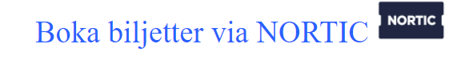

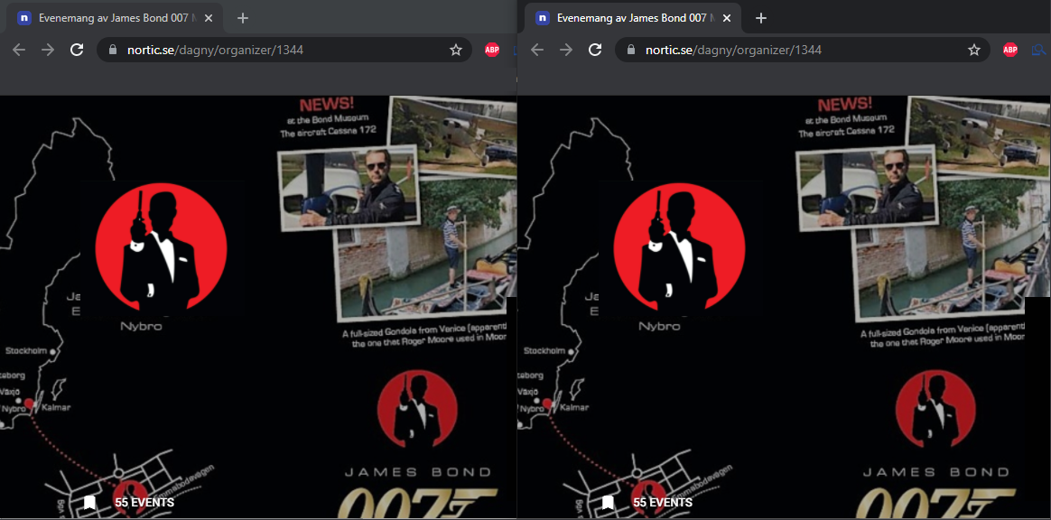

Some of the links on the page are expired links but they are not updated or deleted

**Description:**

Some of the links on the page no longer work, but are not updated or deleted.

**Used Device/Browser:**

- Chrome (Version 91.0.4472.77 (64-bit)) on Windows 10

**Steps to reproduce:**

* Open the <http://www.007museum.com/> page
* Scroll down and find the below mentioned hyperlinks on the page.
* Click on the first paragraph on the site just under the banner. Observe that the link is expired.

**The links that no longer work:**

This entire paragraph (with the exception of the bold title) is a link that does not work

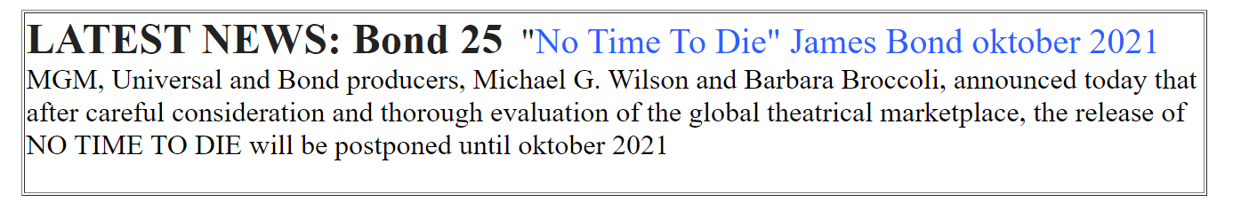

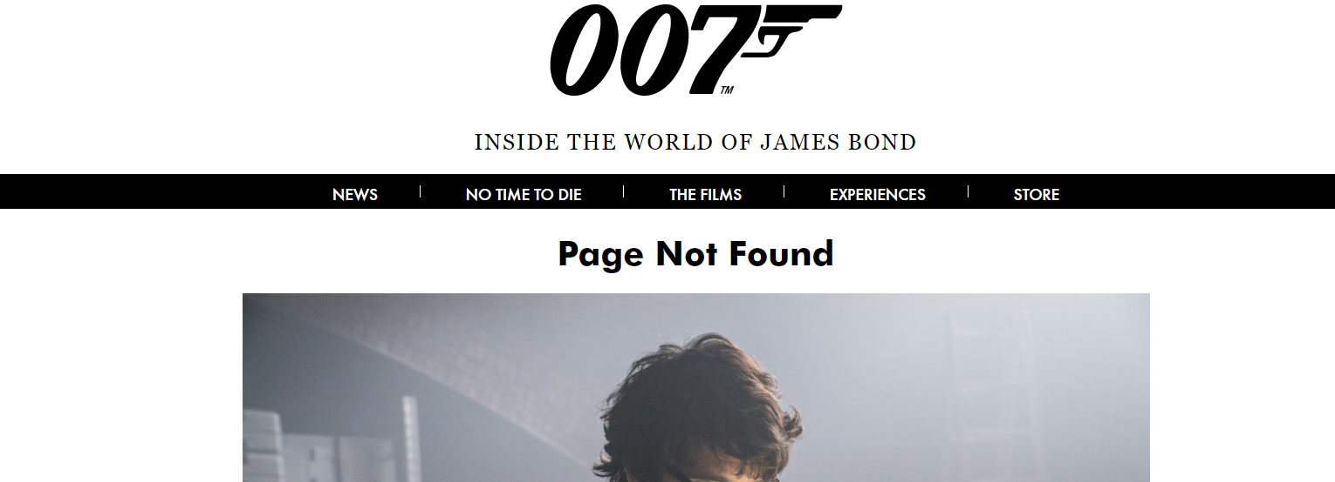

It is hard to discern what is a video and what is an image

**Description:**

In the example screenshot down below you can see there are 4 objects that look like videos, but two are images and two are videos.

**Used Device/Browser:**

- Chrome (Version 91.0.4472.77 (64-bit)) on Windows 10

**Steps to reproduce:**

* Open the <http://www.007museum.com/> page
* Scroll down the page and find the objects that look like videos from the screenshot.
* Click on the first video and observe as the video starts to play.
* Click on the second video and observe as the video starts to play.
* Click on the third object that looks like a video and observe that it actualy takes you to another site and actually is an image hyperlink.
* Click on the last object that looks like a video and observe that it actually is an image hyperlink that takes you to another page from this site.

**Screenshot:**

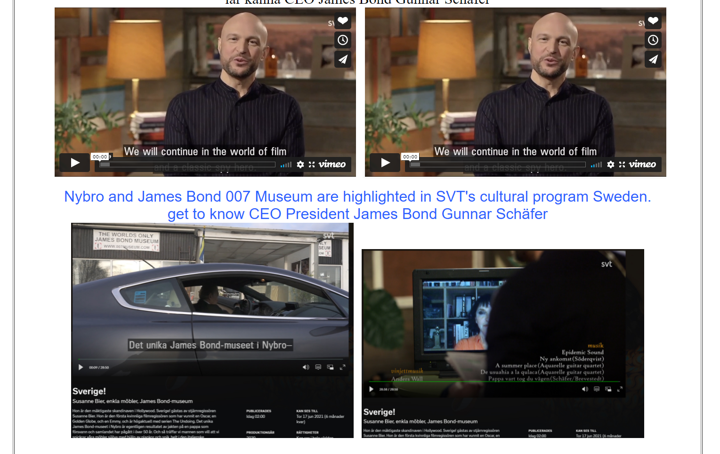

There is no difference in the link and text

**Description:**

In the example screenshot down below the first part of the text is a link and the rest is a basic text.

**Used Device/Browser:**

- Chrome (Version 91.0.4472.77 (64-bit)) on Windows 10

**Steps to reproduce:**

* Open the <http://www.007museum.com/> page
* Scroll down the page and find the text from the screenshot.
* Observe that the first part of the text is link and that the rest is text with no visible difference between the two.
* Also, the text has a background color different from the site background, but still to light to highlight the text.

**Screenshot:**



Spacing in the text is not consistent

**Description:**

In the example screenshot down below there is unnecessary white space in between words.

**Used Device/Browser:**

- Chrome (Version 91.0.4472.77 (64-bit)) on Windows 10

**Steps to reproduce:**

* Open the <http://www.007museum.com/> page
* Scroll down the page and find the text from the screenshot.
* Observe that there is too much spacing between some words

**Screenshot:**

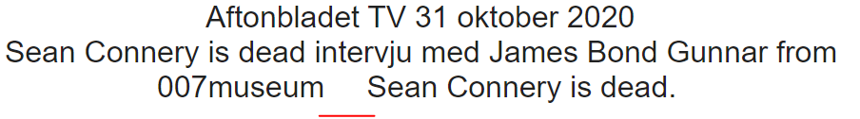

Image formatting is not consistent

**Description:**

In the example screenshot down below You can see that the images have different formats, some are too small and do not expand on hover.

**Used Device/Browser:**

- Chrome (Version 91.0.4472.77 (64-bit)) on Windows 10

**Steps to reproduce:**

* Open the <http://www.007museum.com/> page
* Scroll down the page and find the post from the screenshot.
* Observe that the images have different sizes.
* Hover over the three small images in the middle of the post and observe how they expand
* Hover over the two small images in the bottom of the post and notice how nothing happens.
* Click on the first small image in the bottom and notice that it is actually a hyperlink and leads you to the: <http://www.007museum.com/lazenby_bond.htm> page.
* Click on the second small image and notice that it is also a hyperlink.
* Observe as the new page downloads a music file to your local machine.

**Screenshot:**

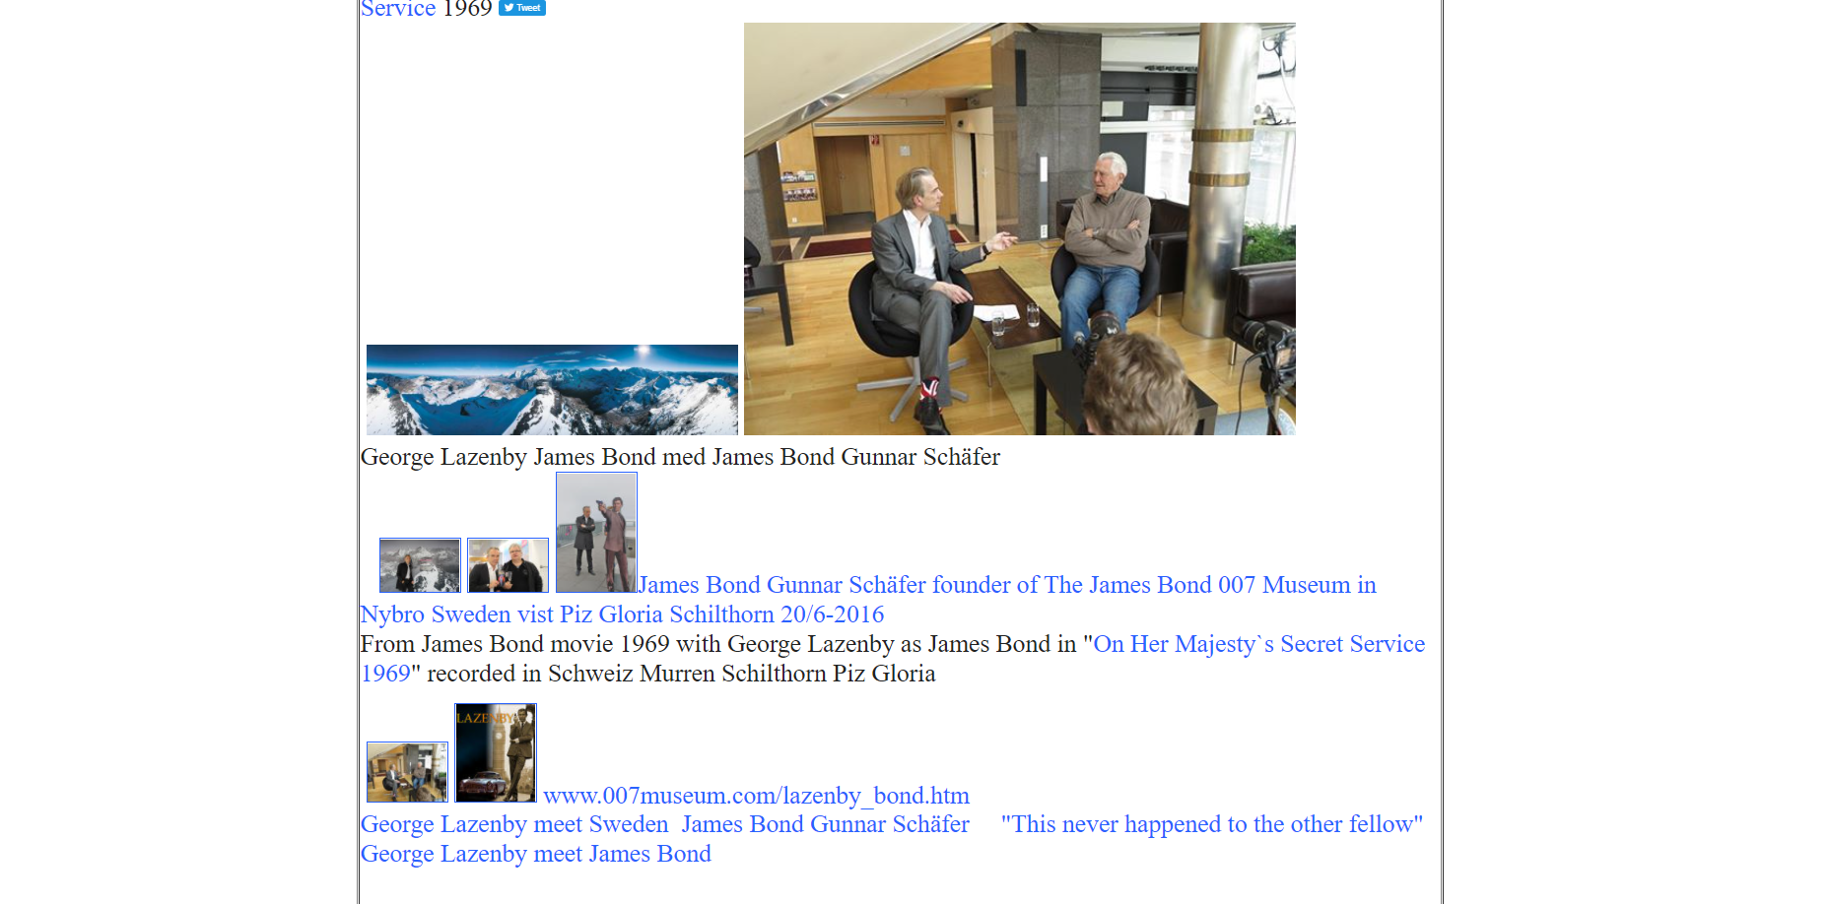Different fonts and font sizes in the same post

**Description:**

In the example screenshot down below there are at least 7 different font sizes.

**Used Device/Browser:**

- Chrome (Version 91.0.4472.77 (64-bit)) on Windows 10

**Steps to reproduce:**

* Open the <http://www.007museum.com/> page
* Scroll down the page and find the text from the screenshot.
* Observe the text and notice that there are at least 7 different font sizes all in one post.
* Also if you hover over the text you will notice that there are no rules to what is a link and what is just plain text.

**Screenshot:**

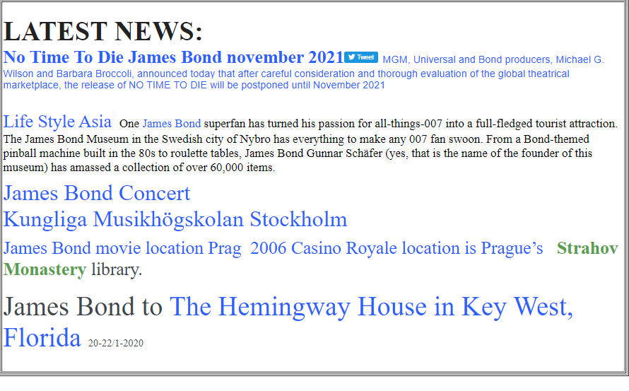

Some posts are not centered

**Description:**

In the example screenshot down below You can see that some osts are not centered properly and are on the left size of the page.

**Used Device/Browser:**

- Chrome (Version 91.0.4472.77 (64-bit)) on Windows 10

**Steps to reproduce:**

* Open the <http://www.007museum.com/> page
* Scroll down the page and find the part of the site from the screenshot.
* Observe location of posts on the site and notice how some of them are not centered properly.
* Continue scrolling down the page and observe how the posts shift from centered to left aligned all the time.

**Screenshot:**

